Types of Number Determiners
# Source: AI Source: Provided by: [Data Path: Persons Table -> ID Column: 1, Name_En Column: Motasem Essam] -> From: [Chatgpt (GPT-4-turbo)] on [7/28/2025]
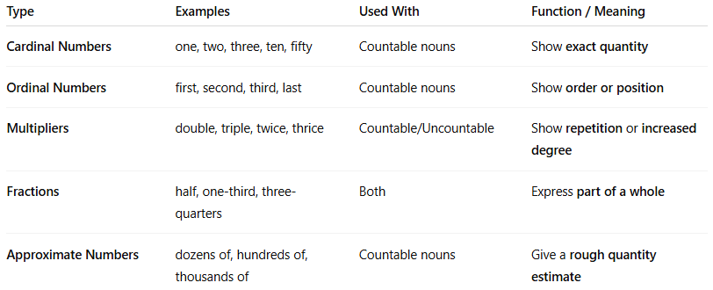

Type | Examples | Used With | Function / Meaning
Cardinal Numbers | one, two, three, ten, fifty | Countable nouns | Show exact quantity
Ordinal Numbers | first, second, third, last | Countable nouns | Show order or position
Multipliers | double, triple, twice, thrice | Countable/Uncountable | Show repetition or increased degree
Fractions | half, one-third, three-quarters | Both | Express part of a whole
Approximate Numbers | dozens of, hundreds of, thousands of | Countable nouns | Give a rough quantity estimate

